Document Distribution

The Document Distribution feature in Solvas|Digitize displays a list of distribution rules that enable transfer of the reconciled documents to the downstream application(s). Solvas|Digitize distributes documents using two types of transfer mediums:
- Email Distribution: The documents are sent downstream through emails.
- File Folder Transfer: The documents are sent downstream through the file folder transfer.

To view the Document Distribution, navigate to Solvas|Digitize > System Setup > Document Distribution. Using this feature, you can access:
- Distribution Rules: The rules that enable document transfer.
- Email Templates: The templates configured for sending the documents through emails.
- Distribution Queue: The details of the documents queued to be sent through the email distribution and file folder transfer.
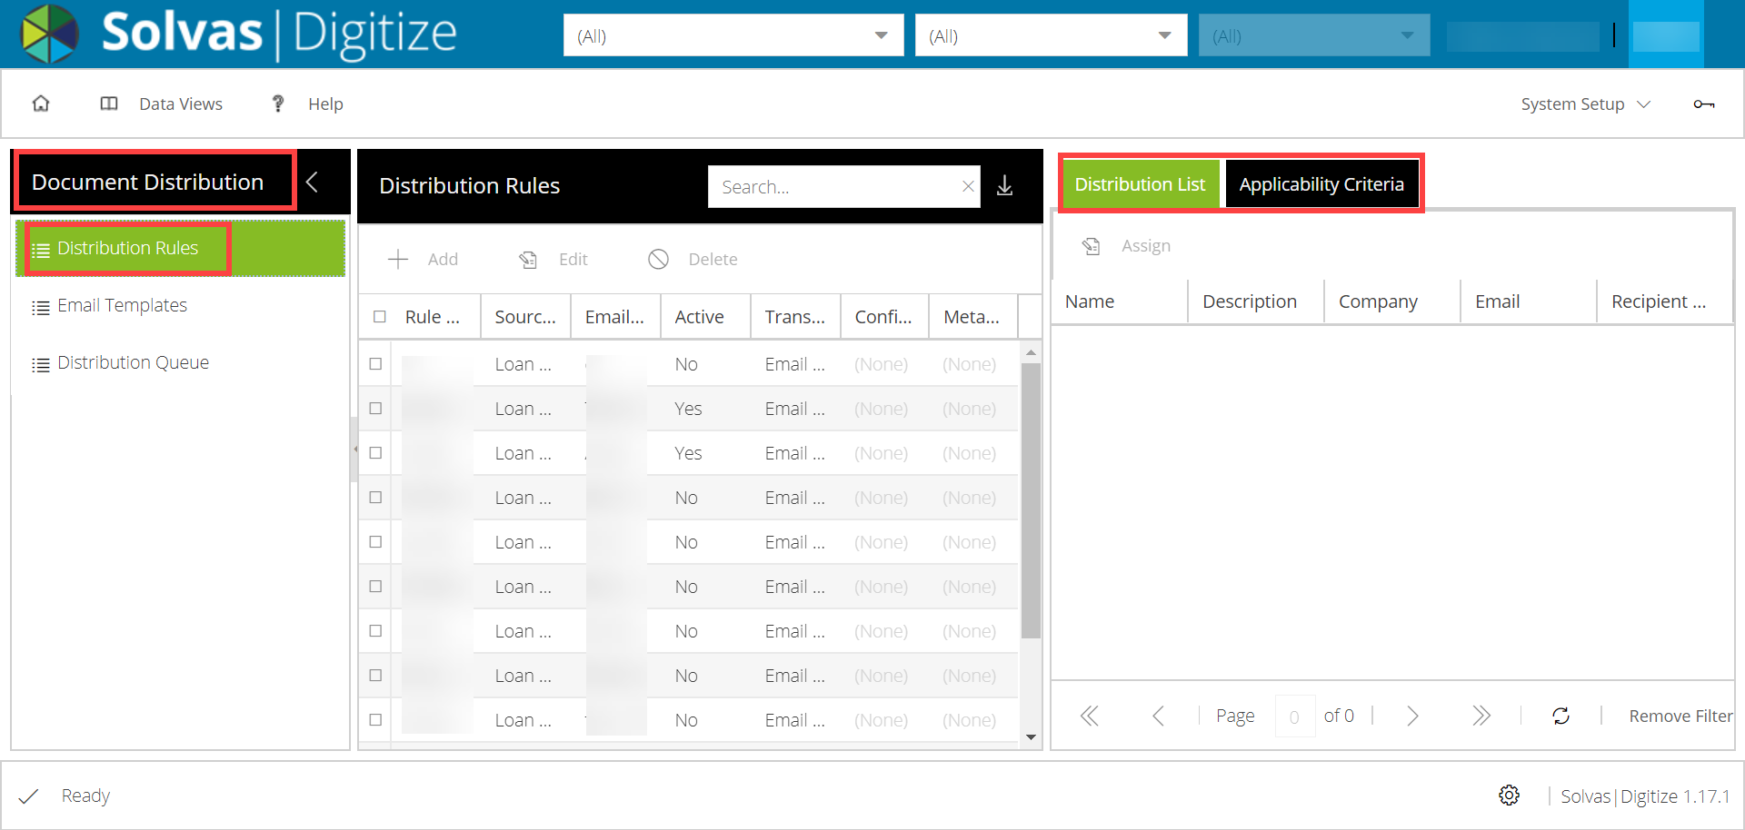
Distribution Rules:
The Distribution Rules tab displays a list of rules based on which the reconciled documents are transferred to the downstream application(s) when the corresponding applicability criteria matches.
Refer to each field that appears in the Document Rules tab as described in the following table.
Field | Description
Rule Description | The description of the rule.
Source Dataset | The dataset associated with the documents.
Email Template | The email template selected for sending the documents downstream. This field will be empty in case of the file folder transfer.
Active | The status of the distribution list.
Transfer Type | The type of transfer associated with the distribution of the document, such as email distribution or file folder transfer.
Configuration Name | The configuration name associated with the file folder transfer. This field will be empty in case of the email distribution.  Note: The configuration name is defined in the System Setup > Communication Interface > Outgoing Data.
Metadata Rule Name | The metadata rules associated with the document distribution.

Each distribution rule is associated with a distribution list and the relevant applicability criteria. A distribution list displays the email distribution details of the recipients as described in the following table:
Field | Description
Name | The name of the recipient (it could be an individual or a contact group).
Description | Description that provide additional information of the distribution list. This is an optional field.
Company | The company to which the documents are sent. This is an optional field.
Email | The email address to which the document will be sent.
Recipient Options | The available options to select recipient types such as To, Cc, and Bcc.

Note: The Distribution List tab is enabled only for the email distribution.

Creating the Distribution Rules
You must choose the appropriate transfer type before you create a distribution rule. Once you create the distribution rule, you can assign the distribution list and define the applicability criteria for it.
To do this:
- Go to Solvas|Digitize > System Setup > Document Distribution. The Distribution Rule page opens.
- Click Add. The Add Distribution Rule window opens.
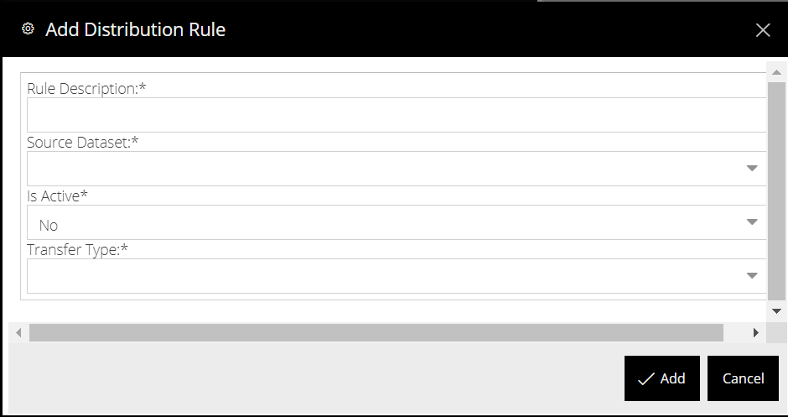
- In the Add Distribution Rule window, specify the appropriate options as described in the following table.
Field | Description
Rule Description | Enter a description for the distribution rule.
Source Dataset | Select the dataset of the source documents.
Is Active | Select the status of the distribution rule.
Transfer Type | Select the transfer type for this document distribution. The available options are file transfer and email distribution.
- Click Add. The distribution rule is created.

Assigning the Distribution List
After the distribution rule is created, you can assign a distribution list to the rule. You can assign a distribution list only for email distribution.
- Go to Solvas|Digitize > System Setup > Document Distribution. The Distribution Rule page opens.
- Select an email distribution rule from the list. The Distribution List tab is enabled.
- Select a distribution list and click Assign in the Distribution List pane. The Manage Distribution List window opens.
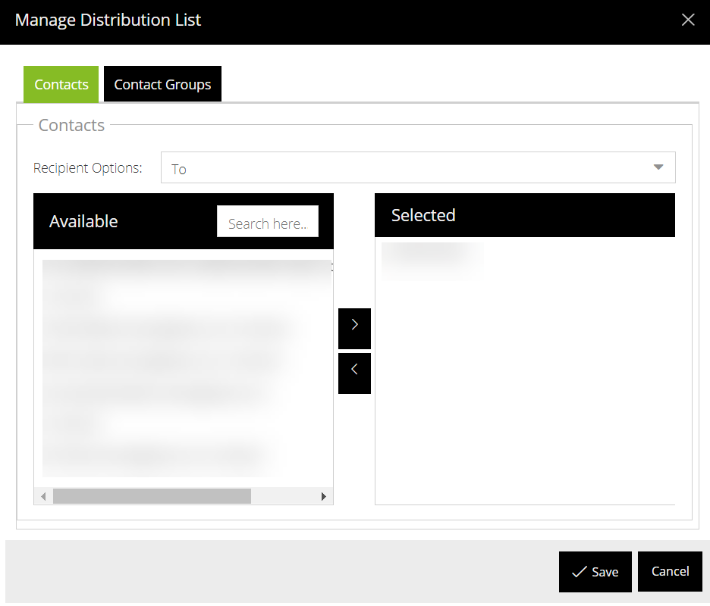
- Select the type of recipients from the Recipient Options drop-down list. The available options are To, Carbon copy (Cc), and Blind carbon copy (Bcc).
- Select the appropriate Contacts and Contacts Groups from the list to add them to the distribution list and then click Save.
Note: The contacts and contact groups are defined in the System Setup>Contact Management.
The selected contacts are added as a distribution list for this distribution rule.

Creating Applicability Criteria
The applicability criteria are the conditions that trigger document distribution whenever these conditions are met.
- Go to Solvas|Digitize > System Setup > Document Distribution. The Distribution Rule page opens.
- Select a distribution rule and click Applicability Criteria.
- Click Add in the Applicability Criteria pane. The Add Applicability Criteria window opens.
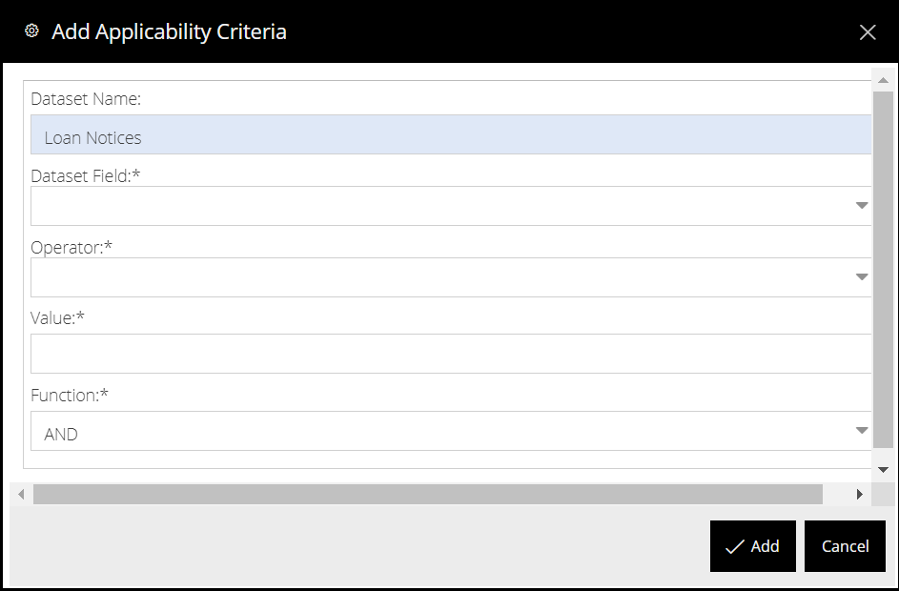
- In the Add Applicability Criteria window, specify the appropriate options as described in the following table.
Field | Description
Dataset name | By default, the Loan Notices dataset is populated in this field.
Dataset Field | The field to which you want to assign the applicability criteria.
Operator | The operator of the rule.
Value | The target value of the selected dataset field.
Function | The ‘AND’ and ‘OR’ operators to add additional conditions for the rule.

- Click Add. The applicability criteria is created.

Modifying the Distribution Rules
You can modify whenever you want to change the transfer type, distribution list, or the applicability criteria associated with a distribution rule.
- Go to Solvas|Digitize > System Setup > Document Distribution. The Distribution Rule page opens.
- Select the distribution rule that you want to modify and click Edit. The Edit Distribution Rule window opens.
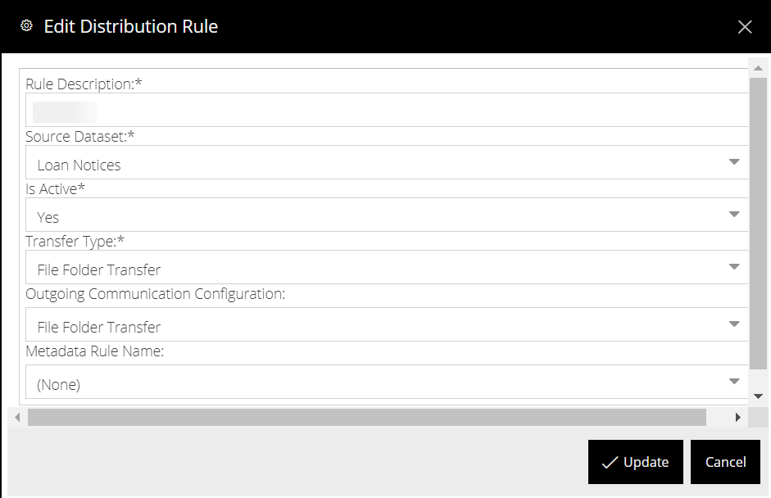
- As needed, modify the distribution rule, and then click Update. The changes made to the distribution rule are saved.

Deleting the Distribution Rule
You can delete a distribution rule if it is no longer needed.
- Go to Solvas|Digitize > System Setup > Document Distribution. The Distribution Rule page opens.
- Select the distribution rule that you want to delete and click Delete. A message appears asking you to confirm.
- Click Continue. The distribution rule and the distribution list and applicability criteria associated with this distribution rule are deleted.

Email Templates:
The Email Templates page displays a list of pre-formatted templates that Solvas|Digitize can use to send emails to the recipients quickly and easily. Using this feature, you can create an email template, modify the template subject or email body, as needed.
Note: The email templates are necessary only for the Email distribution.

Creating the email template
You must configure an email template before you select it as a template for sending emails to the recipients.
To create an email template:
- Go to Solvas|Digitize > System Setup > Document Distribution > Email Templates. The Email Templates page opens.
- Click Add. The Add Email Template window opens.
- In the Add Email Template window, specify the appropriate options as described in the following table.
Field | Description
Name | Enter a name for the email template that you want to create. A value is required in this field.
Description | Enter a detailed description of the email template.
Subject | A value appears in this field, by default.
Body | Specify the body of the email template.
- Click Add. An email template is created.

Modifying the Email Templates
You can modify an email template whenever you want.
- Go to Solvas|Digitize > System Setup > Document Distribution > Email Templates. The Email Templates page opens.
- Select the email template that you want to modify and click Edit. The Edit Email Template window opens.
- As needed, modify values the template details, and then click Update. The changes made to the email template are saved.

Deleting the Email Templates
You can delete an email template if it is no longer needed.
- Go to Solvas|Digitize > System Setup > Document Distribution > Email Templates. The Email Templates page opens.
- Select the email template that you want to delete and click Delete. The selected email template is deleted.
Note: You cannot delete a template if it is assigned to a distribution rule.

Distribution Queue
The Distribution Queue page displays the documents queued for distribution through email and File folder transfers.
Refer to each field that appears in the Email Queue page as described in the following table.
Field | Description
Queue Message ID | The system generated unique ID of the queue.
Rule Description | The description of the distribution rule.
Email Address | The email address of the recipient.
Email Type | The type of email, such as transactional or one-to-many sent to the recipients.
Email Template | The template selected for the email distribution.
Subject | The subject of the email.
Update Date | This displays the date and time at which the email is sent.
Status | The status of the email queue. The available options are:  - Complete – All the documents are sent successfully.  - Partially completed – Some of the documents are sent.  - Failed – The documents were not sent.  - Queued – The documents are in the queue.

Refer to each field that appears in the File Transfer Queue page as described in the following table.
Field | Description
Queue Message ID | The system generated unique ID of the queue.
Rule Description | The description of the file transfer distribution rule.
Transfer Type | The File folder transfer type of the documents.
Configuration Name | The name of the configuration setup in the communication interface for the file folder transfer.
Destination | The destination of the file transfer.
Update Date | This displays the date and time at which the file transfer is sent.
Status | The status of the email queue. The available options are:  - Complete – All the documents are sent successfully.  - Partially completed – Some of the documents are sent.  - Failed – The documents were not sent.  - Queued – The documents are in the queue.

The File Transfer Queue displays the records queued to transfer the documents through file folder transfer.

